Time | Minutes | Grade Level
9:00-9:30 | 30 | Word Study (M, W)  Guided Reading (T, TH)
9:30- 9:50 | 20 | Writing Instruction(M,W)  Math Instruction (T,Th)
9:50- 10:00 | 10 | Movement Block
10:00- 10:30 | 30 | Math Instruction(M, W)  Daily Read Aloud/ Calendar Activities (T, TH)
10:30-11:00 | 30 | Science and PE/ Health Integrated Activity(M, W)  Social Studies and Music/ Art Integrated Activity
11:00-11:50 | 50 | Tutoring
12:00-1:00 | 60 | Lunch
1:00-1:30 | 30 | Word Study(M, W)  Guided Reading (T, TH)
1:30-1:50 | 20 | Writing Instruction(M,W)  Math Instruction (T,Th)
1:50-2:00 | 10 | Movement Block
2:00-2:30 | 30 | Math Instruction(M, W)  Daily Read Aloud/ Calendar Activities (T, TH)
2:30-3:00 | 30 | Science and PE/ Health Integrated Activity(M, W)  Social Studies and Music/ Art Integrated Activity
3:00-3:50 | 50 | Tutoring
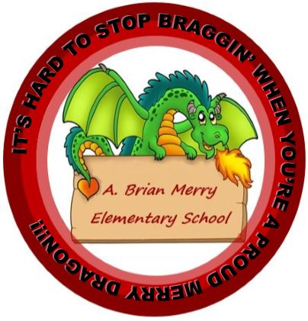
A.B. Merry Elementary
Schedule 2020-2021

Grade: 3rd Teacher: K. Taylor Room: 307

